
SRM Institute of Science and Technology
Mode of Exam
OFFLINE
College of Engineering and Technology
School of Computing
(Common to all Branches)
DEPARTMENT OF COMPUTING TECHNOLOGIES
SRM Nagar, Kattankulathur – 603203, Chengalpattu District, Tamilnadu
Academic Year: 2023-24 (ODD)
Test: CLA1T2 Date: 9.10.2023
Course Code & Title: 21CSS201T COA Duration: 100 minutes
Year & Sem: II & III SET C Max. Marks: 50

Course Articulation Matrix:

Course Learning Outcomes (CLO) | At the end of this course, learners will be able to: | PO 1 | PO 2 | PO 3 | PO 4 | PO 5 | PO 6 | PO 7 | PO 8 | PO 9 | PO 10 | PO 11 | PO  12
CO-2 | Apply Boolean algebra as related to designing computer logic, through simple combinational and sequential logic circuits | H | H |  |  | - | - | - | - | - | - | - | -
 |  | H | H | - | - | - | - | - | - | - | - | - | -

Part – A
(10 x 1 = 10 Marks)
Instructions: Answer all
Q. No | Question |  | Marks | BL | CO | PO | PI Code
1. | The Instruction fetch phase ends with _________  a) Placing the data from the address in MAR into MDR  b) Placing the address of the data into MAR  c) Completing the execution of the data and placing its storage address into MAR  d) Decoding the data in MDR and placing it in IR  Ans : d |  | 1 | 1 | 2 | 2 | 2.1.2
2 | In the case of, Zero-address instruction method the operands are stored in _____  a) Registers  b) Accumulators  c) Push down stack  d) Cache  Ans : c |  | 1 | 1 | 2 | 2 | 2.1.2
3 | In the following indexed addressing mode instruction, MOV 25(R1), LOC the effective address is ______  a) EA = 25+R1  b) EA = R1  c) EA = [R1]  d) EA = 25+[R1]  Ans : d |  | 1 | 2 | 2 | 2 | 2.1.2
4 | _____ addressing mode is most suitable to change the normal sequence of execution of instructions.  a) Relative  b) Indirect  c) Index with Offset  d) Immediate  Ans : a |  | 1 | 2 | 2 | 2 | 2.1.2
5 | Which of the following is/are true of the auto-increment addressing mode?  I. It is useful in creating self-relocating code.  II. If it is included in an Instruction Set Architecture,  then an additional ALU is required for effective  address calculation.  III. The amount of increment depends on the size of the data item accessed.  a) I only  b) II only  c) III Only  d) I and III only  Answer: c |  | 1 | 3 | 2 | 2 | 2.1.2
6 | Using Booth’s Algorithm for multiplication, the multiplier -57 will be recoded as  a) 0 -1 0 0 1 0 0 -1  b) 1 1 0 0 0 1 1 1  c) 0 -1 0 0 1 0 0 0  d) 0 1 0 0 -1 0 0 1  Answer: a) |  | 1 | 2 | 2 | 2 | 2.1.3
7 | A processor that has carry, overflow and sign flag bits as part of its program status word (PSW) performs addition of the following two 2’s complement numbers 01001101 and 11101001. After the execution of this addition operation, the status of the carry, overflow and sign flags, respectively will be:  a) 1, 1, 0  b) 1, 0, 0  c) 0, 1, 0  d) 1, 0, 1  Answer: (B) |  | 1 | 1 | 2 | 2 | 2.1.3
8 | Which of the following addressing modes permits relocation without any change whatsoever in the code?  a) Indirect addressing  b) Indexed addressing  c) Base register addressing  d) PC relative addressing  Answer: d) |  | 1 | 3 | 2 | 2 | 2.1.2
9 | IEEE double precision representation for (1259.125)10?  A.0100000010010011101011001....  B.1100000010010011101011001....  C.1111000010010011101011001....  D.0100001110010011101011001....  Answer:A |  | 1 | 2 | 2 | 2 | 2.1.2
10 | When 1101 is used to divide 100010010 the remainder is ______  a) 101  b) 11  c) 0  d) 1  Answer : d) |  | 1 | 2 | 2 | 1 | 2.1.2
Part – B
( 4 x 4 = 16 Marks)
Instructions: Answer any 4
11 |  | In X = (M + N x O)/(P x Q), how many one-address instructions are required to evaluate it?  Ans: In One-address instructions, an accumulator register is required to perform all the instructions. Load and store operations are performed to fetch the values of operands from registers or memory to accumulators and to store the value of accumulator to a memory location. Instructions required to execute the code:  X = (M + N x O)/(P x Q)  1) Load A : ACC <-- M[M]  2) Add N : ACC <-- ACC + M[N]  3) Mul O : ACC <-- ACC x M[O]  4) Store T : M[T] <-- ACC  5) Load P : ACC <-- M[P]  6) Mul Q : ACC <-- ACC x M[Q]d  7) Div T : ACC <-- M[T] / ACC  8) Store X : M[X] <-- ACC  8 one-address instructions are required to evaluate it | 4 | 2 | 2 | 2 | 2.1.2
12 |  | Registers R1 and R2 of a computer contain the decimal  values 1200 and 4600. What is the effective address of  the memory operand in each of the following  instructions?  a) Load 20(R1), R5  b) Store R5, 30(R1,R2)  c) Add −(R2), R5  Answer:  a) 1220  (Explanation: R1=1200, 20(R1)=&gt; EA=[R1] +  20 = 1200 + 20 =1220)  b) 5830  (Explanation:  R1=1200, R2=4600,  30(R1, R2)=&gt;  EA=[R1] +[R2] + 30 = 1200 + 4600 + 30  = 5830)  c) 4599  (Explanation:  R2=4600, -(R2) =&gt; R2 = [R2] - 1  = 4600 -1 =4599, EA = [R2] = 4599) | 4 | 2 | 2 | 2 | 2.1.2
13 |  | Write a program to evaluate the given arithmetic expression Z = ( R + P ) * E + K * B - L / G - S  ii) Using a general register computer with two address and three address instructions.  iii) Using an accumulator type computer with one address instructions.  iv) Using a stack organized computer with zero-address operation instructions.  v) Using RISC computer instruction format  State the principle of operation of a carry look-ahead adder and write the equation for carry propagate and generate function with diagram.  The input carry needed by a stage is directly computed from carry signals obtained from all the preceding stages i-1,i-2,…..0, rather than waiting for normal carries to supply slowly from stage to stage. An adder that uses this principle is called carry look-ahead adder.  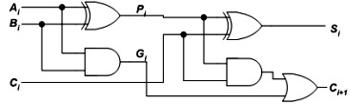  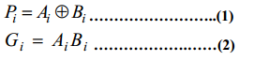 | 4 | 2 | 2 | 2 | 2.4.1
14 |  | Give the booth’s recoding and bit-pair recoding of the computer. 1000111101000101  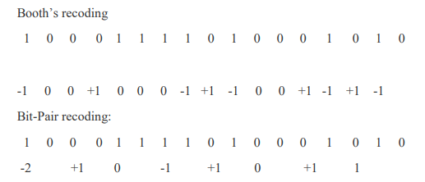 | 4 | 2 | 2 | 2 | 2.4.1
15 |  | In conforming to the IEEE standard mention any four situations under which a processor sets exception flag.  Underflow:  If the number requires an exponent less than -126 or in a double precision, if the number requires an exponent less than -1022 to represent its normalized form the underflow occurs.  Overflow:  In a single precision, if the number requires an exponent greater than -127 or in a double precision, if the number requires an exponent greater than +1023 to represent its normalized form the underflow occurs.  Divide by zero:  It occurs when any number is divided by zero.  Invalid:  It occurs if operations such as 0/0 are attempted. | 4 | 2 | 2 | 2 | 2.1.3
PART C

( 12 x 2 = 24 Marks)
Instructions: Answer all
16 |  | Consider the following memory values and a one-address machine with an accumulator, what values do the following instructions load into accumulator?  - Word 20 contains 40  - Word 30 contains 50  - Word 40 contains 60  - Word 50 contains 70  Instructions are-  - Load immediate 20  - Load direct 20  - Load indirect 20  - Load immediate 30  - Load direct 30  - Load indirect 30  Ans: ( Each Instruction carries 2 Marks)  Instruction-01: Load immediate 20  - This instruction uses immediate addressing mode.  - The instruction is interpreted as Accumulator ← 20.  - Thus, value 20 is loaded into the accumulator.  Instruction-02: Load direct 20  - This instruction uses direct addressing mode.  - The instruction is interpreted as Accumulator ← [20].  - It is given that word 20 contains 40.  - Thus, value 40 is loaded into the accumulator  Instruction-03: Load indirect 20  - This instruction uses indirect addressing mode.  - The instruction is interpreted as Accumulator ← [[20]].  - It is given that word 20 contains 40 and word 40 contains 60.  - Thus, value 60 is loaded into the accumulator.  Instruction-04: Load immediate 30  - This instruction uses immediate addressing mode.  - The instruction is interpreted as Accumulator ← 30.  - Thus, value 30 is loaded into the accumulator.  Instruction-02: Load direct 30  - This instruction uses direct addressing mode.  - The instruction is interpreted as Accumulator ← [30].  - It is given that word 30 contains 50.  - Thus, value 50 is loaded into the accumulator  Instruction-03: Load indirect 30  - This instruction uses indirect addressing mode.  - The instruction is interpreted as Accumulator ← [[30]].  - It is given that word 30 contains 50 and word 50 contains 70.  - Thus, value 70 is loaded into the accumulator. | 12 | 2 | 2 | 2 | 2.1.3
 |  | OR
17 |  | Design a digital arithmetic circuit having three inputs A, B, and C, and two outputs f₁ and f_{2,}where f₁ and f₂ are  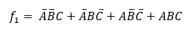  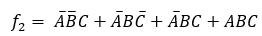  Draw the truth table that satisfies the above SoP expression and perform the minimization of the same using Boolean algebra. Draw an equivalent circuit diagram using a combination of Basic, Universal, and compound gates.  Given, and .  The truth table for the above will be as follows:(3 marks)  Minimization: (3marks)  F1:  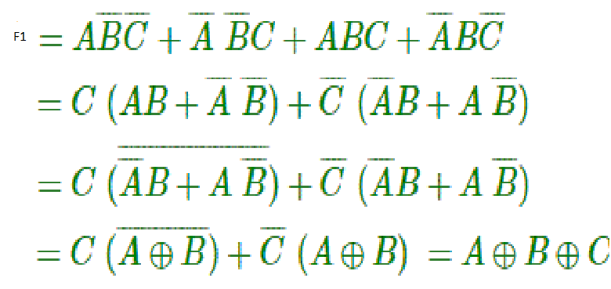  F2: (3 marks)  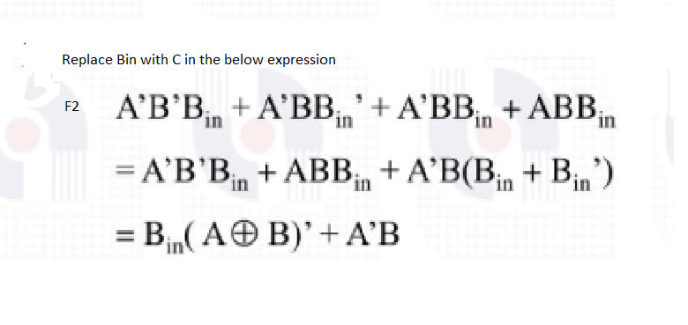  Circuit Diagram: (3 marks  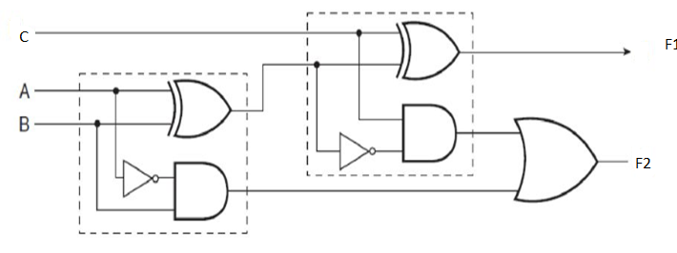 | 12 | 1 | 2 | 2 | 2.1.3
  Input |  |  | Output
  A | B | C | F1 | F2
  0 | 0 | 0 | 0 | 0
  0 | 0 | 1 | 1 | 1
  0 | 1 | 0 | 1 | 1
  0 | 1 | 1 | 0 | 1
  1 | 0 | 0 | 1 | 0
  1 | 0 | 1 | 0 | 0
  1 | 1 | 0 | 0 | 0
  1 | 1 | 1 | 1 | 1
18 |  | Interpret the multiplication of (-10) and (-4) using Booth's algorithm with flowchart  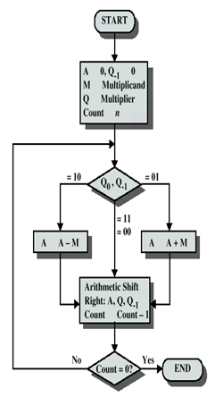  Flow chart (4)  Each iteration 2 marks (4* 2) = (8)  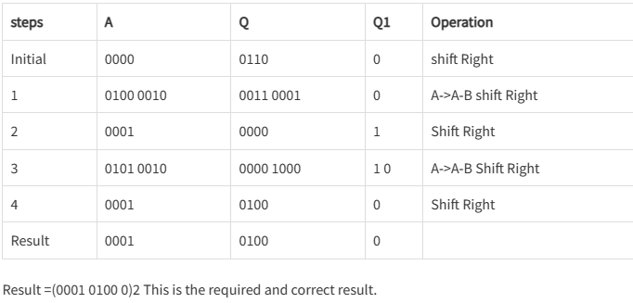 | 12 | 2 | 2 | 2 | 2.1.3
 |  | OR
19 |  | Construct a fast addition process for the below-mentioned binary numbers 1001,1101,1110,1111,1010,1100 by converting a three-operand addition to a two-operand addition.  ii) What is the advantage of using the fast addition process in comparison to the other addition processes and state where it is used?  Carry save Addition Answer:  Identify A,B,C,D,E,F – 1 MARK  G1- 2 MARKs,  G2 -2 MARKs,  G3- 2 MARKs,  G4 – 2 MARKs  FINAL ANSWER:  Sum =010001  carry=111000 | 12 | 2 | 2 | 2 | 2.1.3
Ans |  | 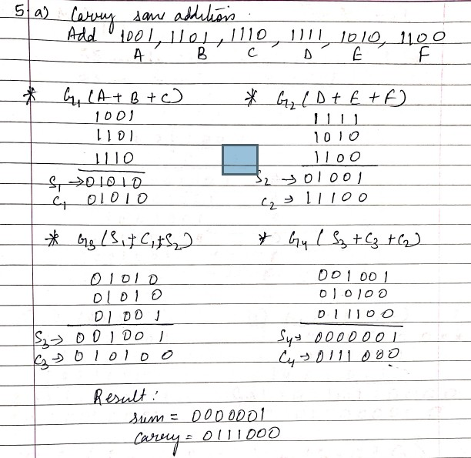
II) A) Advantage of this process:
Carry save adder is very fast and cheap adder, it does not propagate carry bits.(1.5 marks)
b) Application:
This is used in Binary Multiplier. (1.5 marks)

*Performance Indicators are available separately for Computer Science and Engineering in AICTE examination reforms policy.

Course Outcome (CO) and Bloom’s level (BL) Coverage in Questions

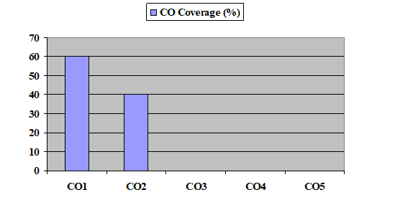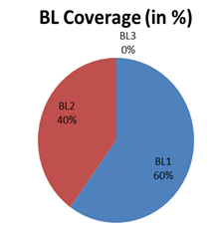

Approved by the Audit Professor/Course Coordinator

